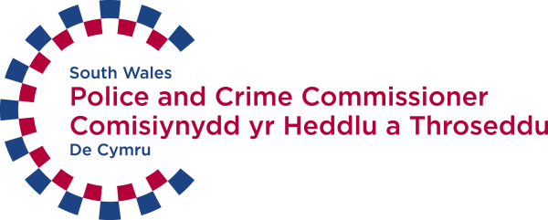

Title: Bilingual Administrative Assistant
Employer: Police and Crime Commissioner for South Wales
Location: South Wales Police Headquarters, Cowbridge Road, Bridgend, CF31 3SU
Responsible to: Commissioner’s Personal Assistant/Office Manager
Liaison with: Commissioner, Assistant Commissioners, Chief Officers, Commissioner’s Support Staff, Police and Support Staff of South Wales Police, the public, and external agencies.
Hourly Rate: £7.94
Hours Worked: 37 hours – Monday to Friday
Contract Type: 12 months

Background
This opportunity will give someone who is eager and keen to learn key administrative skills in the setting of a busy, friendly and high-profile office, working closely with an immediate team of three experienced staff– the Commissioner’s Personal Assistant/Office Manager, and the two Secretaries to the Assistant Commissioners and Chief Officers.
The post is based at South Wales Police Headquarters in Bridgend, home to Wales’ largest and busiest Police Force.
After a trial period on placement (to see if you like the work and if we can offer you an Apprenticeship) you could go on to a full Apprenticeship where we will support you in achieving an NVQ level 2 or 3 of your choice - in Customer Service, IT or Business Administration.

Job Description
Main duties
Support the Commissioner’s Administration Team in all aspects of their duties which include:
Reception – meeting and greeting visitors (bi-lingually in Welsh and English), preparing refreshments, keeping reception area tidy
Booking and preparing rooms for meetings
Telephone answering (members of the public, partner agencies, Police and Police staff in Welsh and English)
Receipt and despatch of mail to and from the office, including emails
Document filing and storage, including email and destruction and deletion of documents
Photocopying and scanning documents
Providing and accessing information using a range of IT systems and software such as Microsoft Outlook, Word, Excel, and PowerPoint.
Typing letters, reports and emails in Welsh and English
Booking appointments
Booking accommodation and travel
Planning and supporting meetings e.g. preparation of papers,
Stationery orders, dealing with deliveries and maintenance of stationery cupboard
Maintain safe working practices for self and others
Follow South Wales Police’s Diversity Strategy.

Personal style
Good basic communications skills – able to speak and write clearly in both Welsh and English, ask questions when appropriate, and listen.
Be able to understand and carry out written and verbal instructions
Present a positive, confident, professional, welcoming and helpful attitude to visitors and staff.
A willingness to learn, progress and succeed.
Demonstrate common sense; and a sense of responsibility.
Take pride in their work and is committed to getting it right first time
Respect others and be discreet in safeguarding information.

Aptitude and potential
Good keyboard skills – speed and accuracy.
Good knowledge of basic IT packages such as Windows, Microsoft Office.
Ability to hold conversations and write in Welsh as well as English is essential.
Good team player.
Be able to plan, organise and prioritise own work effectively and adapt to fluctuating workloads, looking for work when things are quieter
Willing to offer to help to colleagues when they are busy.
Identify problems or discrepancies, and draw them to the attention of others.
Be able to ‘multi-task’.
Be tactful, loyal, and diplomatic.
Be self-motivated
Seek feedback on performance
Be enthusiastic, energetic and adaptable
Avoid personal prejudice and do not discriminate.

