Briefing note to the Police and Crime Panel on the way the Police and Crime Commissioner is managing and controlling his team’s budget

- While the role of the Police & Crime Commissioner is considerably more extensive and demanding than the role of the previous police authority – involving a remit for crime reduction and a series of responsibilities devolved by both the Home Office and the Ministry of Justice – the aim from the start has been to contain the cost of the Commissioner’s support team within the envelope of what the South Wales Police Authority cost to do its job.

- This is considerably more challenging that it appears at first sight because the South Wales Police Authority – to its credit – operated on a budget that was amongst the lowest of all police authorities, as shown below:

Police Authority Budgets 2012/13

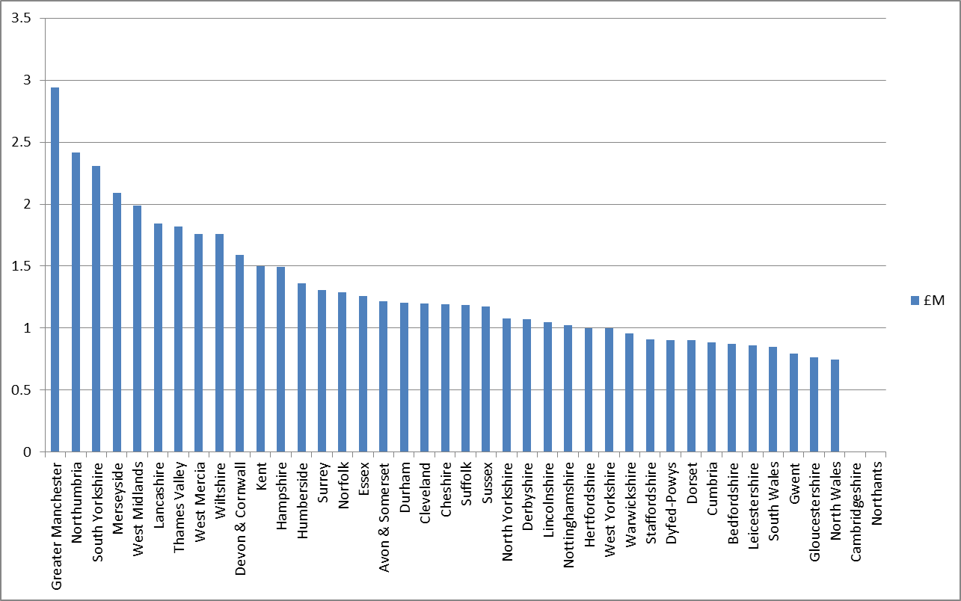

- Intrinsic to any understanding of the Police and Crime Commissioner’s budget is an understanding of the role of the Police and Crime Commissioner, how that role has developed since 2012 and how that role differs from the former Police Authority. The first part of this report will refresh the Panel on the role and functions of the Commissioner. The second part of the report will examine how this translates into budgets.
Role and Functions of the Commissioner

- The key functions of the Police and Crime Commissioner are set out in the following table:

Representing the Public:
- The Police & Crime Commissioner is directly elected by the public and accountable to the electorate for delivering an efficient and effective police force and holding the wider criminal justice system to account.
- The Commissioner has a duty to consult with victims and with communities across South Wales which has a population of 1.3million people.
- He needs to determine the needs of local people and develop or commission services to assist in cutting crime
- He is required to publish information to enable the public to judge the effectiveness of South Wales Police and the performance of the Police and Crime Commissioner
- He has a major role in delivering services to victims (delegated by the Ministry of Justice from April 2015)
Appointment and Scrutiny  - Appoint/dismiss the Chief Constable  - Hold the Chief Constable to account for the running of the force  - Deal with complaints and disciplinary matters relating to the Chief Constable  - Review the local complaints system and scrutinise its efficiency | Strategic Direction  - Set police and crime objectives in consultation with the Chief Constable and communities  - Produce a 5 year Police and Crime Plan based on local priorities and taking account of the Strategic Policing Requirement  - Produce an annual report, with annual accounts
Funding:  - Set the annual budget for South Wales Police and set the precept  - Make grants to other organisations including community safety partnerships (in support of their community safety priorities) | Partnership Working  - Promote joined up working on community safety and criminal justice  - Work with local leaders to improve outcomes for communities and ensure effective and efficient use of resources  - Agree and review collaborative arrangements in consultation with the Chief Constable

- The production of the Police & Crime Plan is important but cannot fully reflect the “creative” element of the role which involves building relationships, developing effective partnerships and co-ordinating disparate organisations. How such leadership roles develop will depend partly on the communities that are served and the demands of the public in the police area but – as an article of personal faith for the Commissioner – must be built on a strong base of evidence of the area’s real problems, effective solutions (“What Works”) and a stringent evidence-based approach. We have developed that approach with care and enthusiasm and South Wales is increasingly seen as the exemplar of the evidence-based approach for which the Commissioner and the Chief Constable are passionate advocates.

- There is much to note from the foregoing table but, in particular, it is important to note that the role of the Police and Crime Commissioner extends far beyond his relationship with the Chief Constable. The responsibilities extend into the wider criminal justice system, services for victims and community safety responsibilities. The functions of the Commissioner are “executive” as well as those of community leadership and scrutiny. Other than the clear executive functions of appointing the Chief Constable and setting the budget, the Commissioner is responsible for the delivery of victims’ services and making grants to a range of organisations. These functions directly impact on the type of support which the Commissioner requires and how that support is funded.

- Since Police and Crime Commissioners were elected in November 2012, their role in the functions set out above has been expanded. In particular:
- Responsibilities previously undertaken by the Home Office, such as Community Safety funding (£3.476m), which includes management of the Drug Intervention Programme, has been transferred to the Commissioner.
- The Ministry of Justice has transferred funding (£1.4m) for the delivery of victims’ services to the Commissioner. This involves a significant increase in the resources for victims from the proceeds of the victims’ surcharge and delivering action on the “Victims’ Pledge”
  - Be open and accountable to victims and witnesses seeking out and acting on their views;
  - Ensure that victims and witnesses get the high quality help and support they need when they need it
  - Make the police more victim-focused and more effective at meeting their needs;
  - Give victims and witnesses an effective voice in the wider criminal justice system
  - Constantly work to develop new ways of delivering justice for victims.
- The Home Office has launched a Police Innovation Fund which is particularly work-intensive for Police and Crime Commissioners who have to submit the bids, though the Panel will be aware of the joined up approach adopted by our Commissioner with the Chief Constable. There is considerable resentment at the fact that the Police Innovation Fund is financed from money top-sliced from the Police Grant. So each bid is an application to have our own money returned – but if successful the money can only be applied to purposes approached by the Home Office and cannot be used for direct policing. Submission of each successful bid means (at best) that the resource is returned to the area from which it was originally taken – and has to be match-funder from police or partner resources. In South Wales, the Commissioner and the Chief Constable decided, in effect, “if this is the only show in town we will use it effectively to cut crime and benefit our communities”. We are proud of the practical focus of our projects – reducing violence, tackling alcohol-related issues, improving the use of ICT by police officers, reducing offending in the 18-25 age group - but that does not change the fact that the Government has deliberately decided to move away from funding policing on the devolved model set out in the 2011 Police Reform and Social Responsibility Act to a centralised model of grant-making which deliberately reduces the funding for mainstream police functions and adds to the workload of both the Commissioner and the Chief Constable and their support teams.

- Returning to the comparison between the budgets of Police and Crime Commissioner and previous Police Authority, it has to be understood that the roles are not the same. The following table compares the statutory responsibilities of police authorities and Police and Crime Commissioners:

Police Authorities | Police and Crime Commissioners
Efficiency and Effectiveness:  To ensure the maintenance of an effective and efficient police force for the police area | Efficiency and Effectiveness:  To maintain an efficient and effective police force for the area
Finance:  To hold the Police Fund and maintain accounts, and to agree the police budget and set the precept | Finance:  To decide the budget, allocate assets and funds to the Chief Constable and set the precept for the area
Planning/Performance:  To publish a Policing Plan prepared by the Chief Constable and to monitor the performance of the Force against the Policing Plan | Planning/Performance  The Police and Crime Commissioner must prepare and publish a police and crime plan.  The Commissioner will scrutinise, support and challenge the overall performance of the force including performance against priorities set within the plan. Hold the Chief Constable to account for the performance of the force’s officers and staff
Collaboration:  To collaborate with other police authorities where such cooperation would be in the interests of efficiency and effectiveness of one or more police forces or police authorities | Collaboration:  Promote collaboration to improve the efficiency and effectiveness of the police force.  Promote collaboration with local agencies, including local councils, NHS and others to reduce crime.  Promote collaboration between the police and other bodies in the Criminal Justice System.
Complaints:  To investigate complaints about the conduct of ACPO rank or where appropriate refer complaints to the Independent Police Complaints Commission | Complaints:  To monitor all complaints made against officers and staff, whilst having responsibility for complaints against the Chief Constable
Appointments:  To appoint the Chief Constable, Deputy Chief Constable and Assistant Chief Constables. | Appointments:  To appoint the Chief Constable.  (In South Wales the Chief Constable has accepted the invitation of the Commissioner to be involved in the appointment of his Deputy, Assistant and senior staff, and the Commissioner sits on the Chief Constable’s panel for the appointment of Deputy and Assistant Chief Constables)
Dismissals:  A Police Authority with the approval of the Secretary of State could call upon a Chief Constable of a police force to retire or resign in the interests of efficiency and effectiveness | Dismissals:  The Police and Crime Commissioner may call upon a Chief Constable to retire or resign
Partnership Working:  The Police Authority has a duty to work together with other “responsible authorities” in formulating and implementing crime and disorder strategic assessment and partnership plans, and in consulting communities about crime and disorder matters | Partnership Working:  The Police and Crime Commissioner is embedded by the 2011 Police Reform Act into the crime & disorder reduction partnership work established by the 1998 Crime and Disorder Act with specific leadership responsibilities.
Commissioning Inspections:
A Police and Crime Commissioner may at any time for a police area request Her Majesty’s Inspectorate of Constabulary to carry out an inspection of a police force
Holding the Criminal Justice System to account :
To hold local criminal justice agencies to account for their performance.: In South Wales this is being pursued through a unique partnership, created by merging the South Wales Criminal Justice Board (which has been chaired and strengthened by the Commissioner) and the Integrated Offender Management Board for South Wales.

- It is clear from the foregoing that the Police and Crime Commissioner not only takes on many of the responsibilities of the former Police Authority but the role is considerably enhanced and expanded, not least in the responsibility for the delivery of community safety and crime reduction and the responsibility for the enhancement of the delivery of criminal justice in the area. The Home Affairs Select Committee commented:
“The 2013/14 budget is the first set by police and crime commissioners themselves. This entails substantial new responsibilities. For example, nine Home Office funding streams – for drugs, crime and community safety – were replaced on 1 April 2013 by the Community Safety Fund, a budget for PCCs (sic) to commission services in their area.”
- Staff in the Commissioner’s Team have absorbed much of the new responsibilities without additional resource. Notable examples include:
- Production of the Police and Crime Reduction Plan – the equivalent was previously undertaken by the Chief Constable;
- Management of the former Community Safety Fund grants, previously administered by the Home Office.
- Management of the Drug Intervention Programme contract
- Management of Victim Support functions previously dealt with by the Ministry of Justice
The Commissioner has welcomed the challenge of taking on these responsibilities so that they can be integrated with the work of the police and our partners and so that our communities can be made safe. But that cannot be achieved without considerably greater workload than was the case for the staff of the previous Police Authority.
- The breadth and depth of the Commissioner’s responsibilities are clear and these extend beyond those of the former Police Authority. Whereas the resources of the Police Authority consisted of elected members, operating as a committee and supported by officers, the Commissioner has to discharge an increased range of functions plus additional executive functions in new areas of responsibility. Given that the Commissioner is a single individual – he and the Chief Constable are the two “Corporations Sole” within South Wales Police - his support team have to be skilled and talented, and this is reflected in the budget which shows that team members are expected to be efficient, effective and highly committed.

Finances of the Commissioner

- The following table shows the budgets and actual expenditure of the Police Authority and Police and Crime Commissioner and his immediate support team since 2010/11:

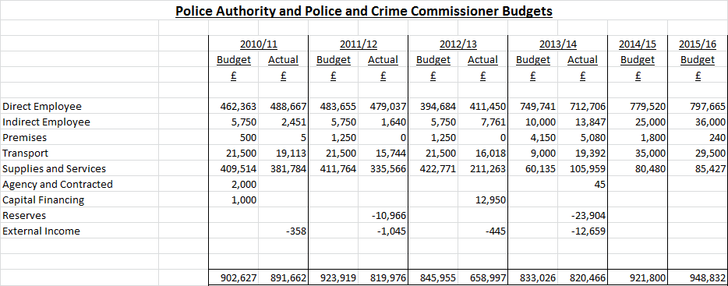

It should be noted that the budget for the Commissioner and his support team has only increased by 2.7% since 2011/12, the last year that the Police Authority was projected to be at full establishment. Effectively, the Commissioner and his support team are now managing the functions previously undertaken by the Police Authority plus the new executive functions outlined in the first part of this report, plus have absorbed much of the inflationary pressure since 2011/12.

- It is worth noting that, according to the Home Affairs Select Committee, South Wales was one of 19 Police and Crime Commissioners’ offices that cost less than the previous Police Authority. The Select Committee also included the following graph, that shows the Commissioner’s budget as one of the lowest as a percentage of the overall police budget:

Police and Crime Commissioner Budget as Percentage of Overall Police Area Budget
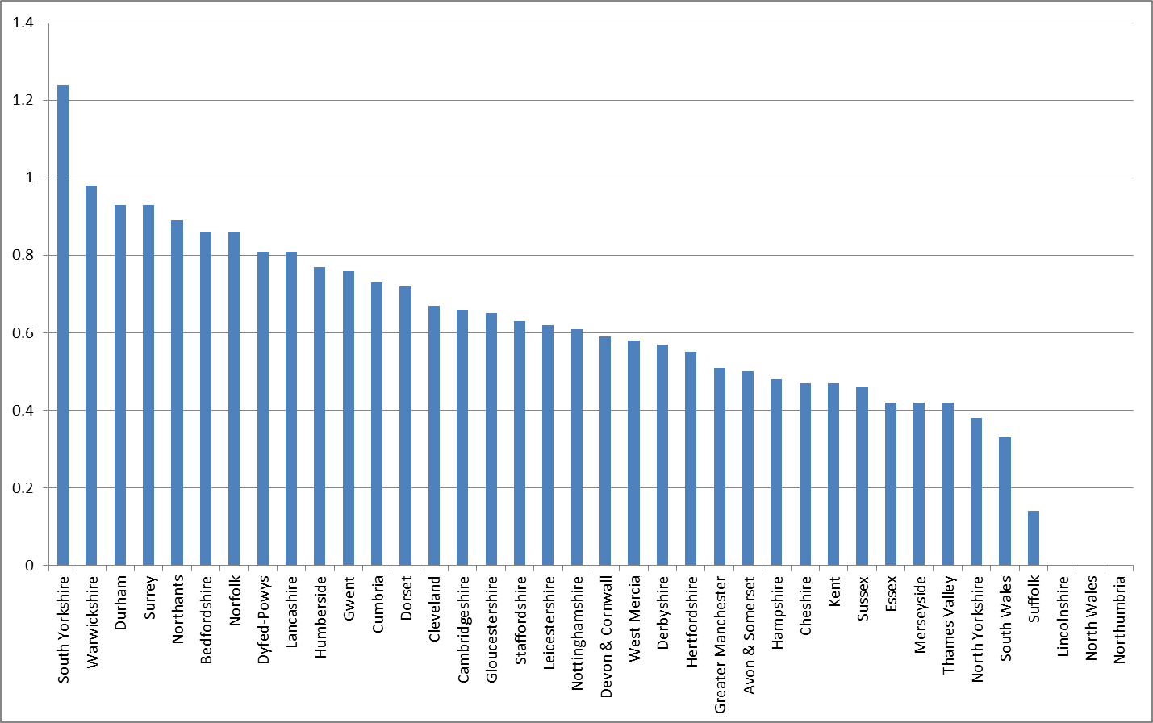

- For reference, Appendix A shows a comparison of the Member and staffing structure of the Police Authority in 2010/11 with the current structure of the Commissioner’s immediate support team.

- In addition to the Commissioner’s immediate support team, South Wales Police – that is the Commissioner and the Chief Constable together - employ project staff to deliver a number of their key initiatives. This links directly to the expansion of the Commissioner’s functions most of which are – in South Wales – pursued jointly with the Chief Constable, The following table summarises the project staff and the relevant funding sources, together with the overall project cost:

Project/Initiative | Overall Cost | Funding Source/s | Full Time Equivalent Staff
Drug Intervention Programme | £2.4m | Previously Home Office, now Police Grant | 4 staff seconded from Probation
Community Safety Funding | £1m | Previously Home Office, now Police Grant | Absorbed within immediate support team
Victims’ Services | £1.4m | Ministry of Justice | 2 FTE
Police Innovation Fund | £0.74m | Home Office funding and South Wales Police Partnership Fund | 4 FTE and 1 seconded staff member from the NHS
Violence against Women and Girls | £60k | Partnership Fund | 2 FTE and 2 contracted staff from the NHS
Partnership Analyst | £43k | Partnership Fund | 1 FTE
Tackling Anti-Social Behaviour | £35k | Partnership Fund/Welsh Government | 1 FTE
Child Sexual Exploitation | £50k | Partnership Fund | 2 staff seconded from expert children’s charities
Mental Health Project | £50k | Partnership Fund | 2 contracted staff

- The Partnership Fund was established in 2012/13, as reported to the Police & Crime Panel at the time, with an initial value of £1m. The Fund has enabled the Commissioner and the Chief Constable to successfully bid to the Home Office’s Police Innovation Fund, bringing £0.5m to South Wales which means that initiatives to tackle issues that have a significant impact on crime levels and community safety, in conjunction with the successful bid for Project Fusion which is providing police officers with direct access to innovative mobile ICT, South Wales has actually recovered more than it lost through the top-slice.

Summary and Conclusion

- The Commissioner is delivering a significantly wider range of functions from a budget which is only fractionally higher than that of the Police Authority. Information from the Home Affairs Select Committee strongly suggests that the financial performance of the Police and Crime Commissioner for South Wales stands in favourable comparison with other Police and Crime Commissioners. In addition, the Commissioner is now directly managing an overall budget in excess of £6m, providing direct services to the people of South Wales. The Commissioner has been able to lever significant additional funding into South Wales through the Innovation Fund and partnership with the Welsh Government.

APPENDIX A : Police Authority and Commissioner’s Team structures

