Estate Information
Premises occupied for the purpose of the work of the Police & Crime Commissioner

Publication Date: 27th July 2018

Photo of Premises | Location | Overview of use
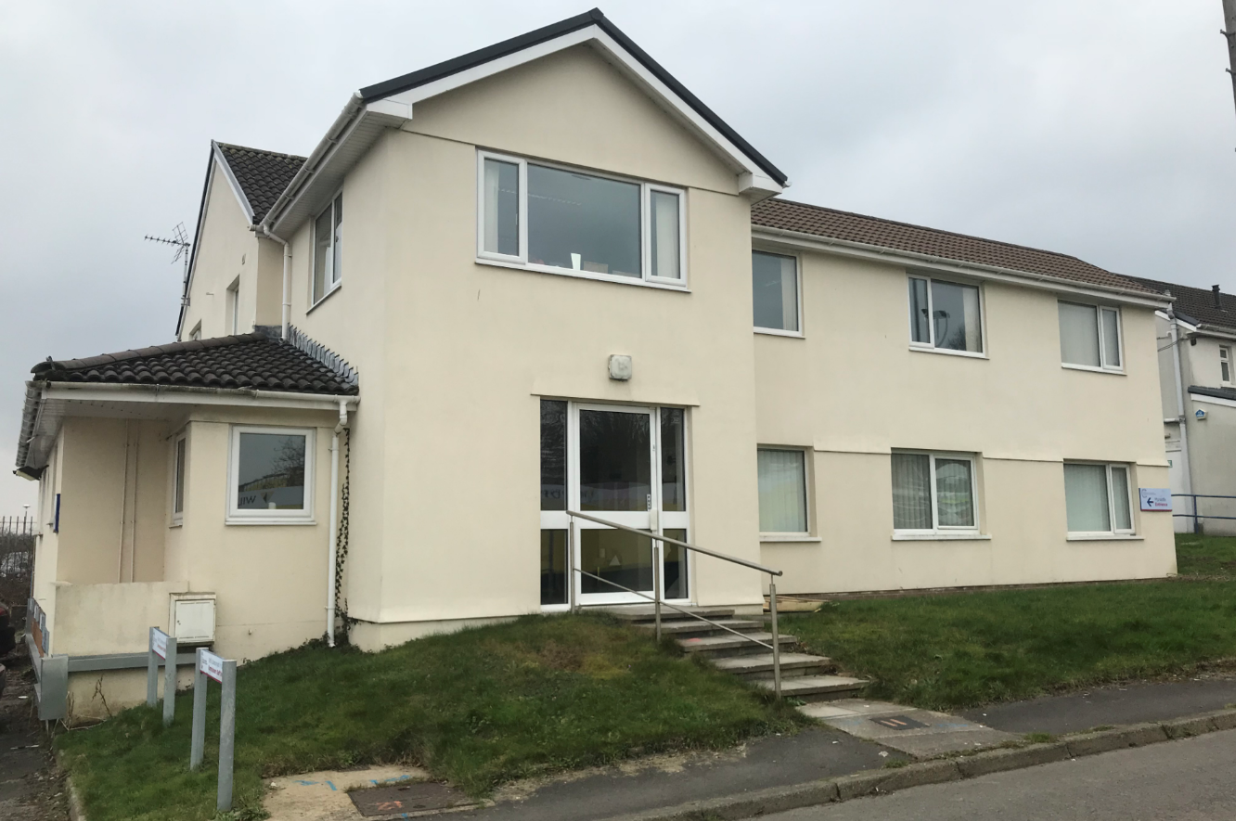 | Ty Morgannwg,  Police Headquarters  Bridgend | This is the main office for the Police & Crime Commissioner.  The Commissioner, his deputy, the Chief of Staff and the Treasurer are all primarily based within this building, alongside administrative support and members of the wider team.
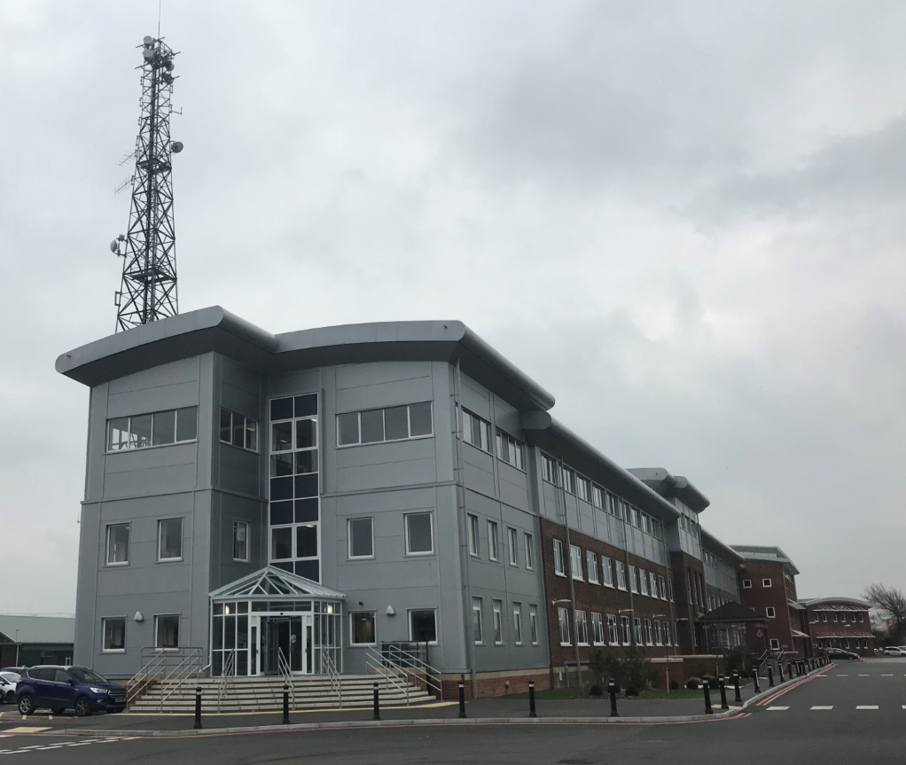 | Main Building,  Police Headquarters  Bridgend | A small number of the Commissioner Team, including the Assistant Commissioners, are based on the 1st Floor of the main Headquarters building.  The team are situated alongside colleagues from the South Wales Police Corporate Development department to complement and enhance project work.
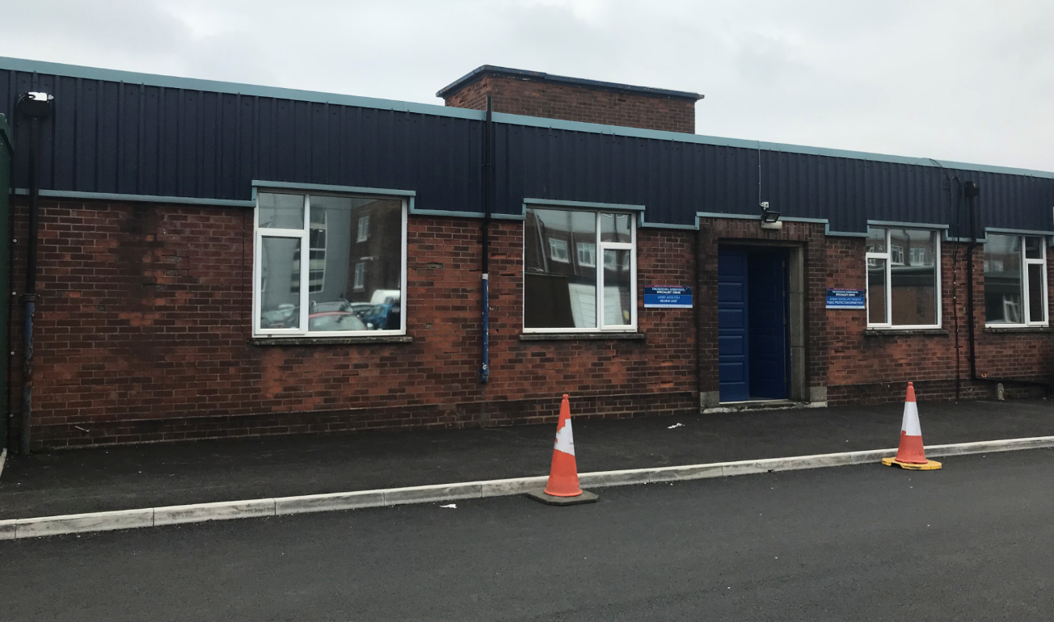 | Public Protection  Police Headquarters  Bridgend | The Commissioners Policy Lead for Violence against Women & Girls is based within the Public Protection Department on the Headquarters site. This co-location alongside operational staff is to enhance joint understanding, policy development and response.
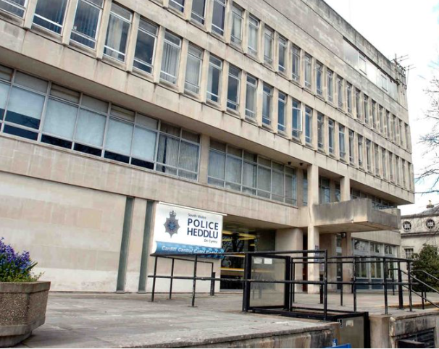 | Cardiff Central Police Station | A small number of ‘satellite’ offices are allocated for use by the Commissioner Team within Cardiff Central Police Station.  Many of the meetings with partners are Cardiff based and therefore this allows members of the team to have a physical base to host these meetings, whilst also providing a dedicated home away from the main Headquarters office to reduce unnecessary travel.

